Practice-1

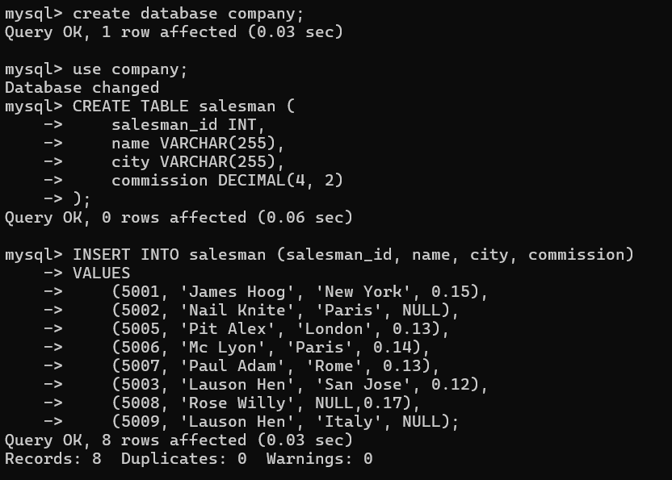

1) Write a SQL statement that displays all the information about all salespeople.

mysql> select * from salesman;

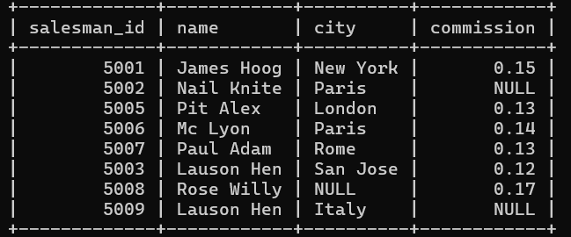

2) Write a SQL statement to display specific columns such as names and commissions for all salespeople.

mysql> SELECT name, commission FROM salesman;

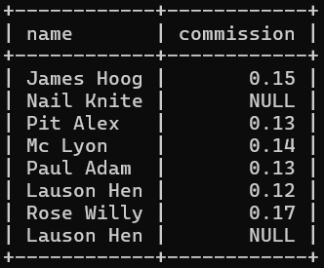

3) Write a SQL query to locate salespeople who live in the city of 'Paris', Return salesperson's name, city.

mysql> SELECT name, city FROM salesman WHERE city='Paris';

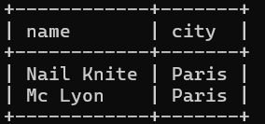

4) write a SQL query to locate salespeople who live in the city of 'San Jose'. Return salesperson's name, commission.

mysql> SELECT name, commission FROM salesman WHERE city='San Jose';

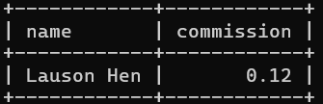

5) Write a SQL statement to display columns such as salesman_id, names and city for all salespeople.

mysql> SELECT salesman_id, name, city FROM salesman;

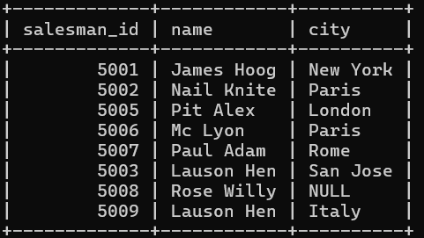

6) Write a SQL query to display columns such as salesman_id, names and city for all salespeople.



7) Write a SQL statement that displays all the information Arranged the output in ascending order by name.

mysql> SELECT * FROM salesman ORDER BY name;

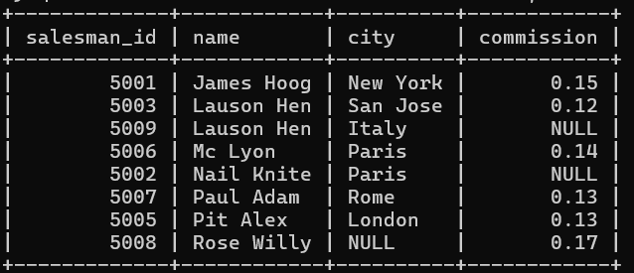

8) Write a SQL statement that displays all the information Arranged the output in ascending order by salesman_id.

mysql> SELECT * FROM salesman ORDER BY salesman_id;

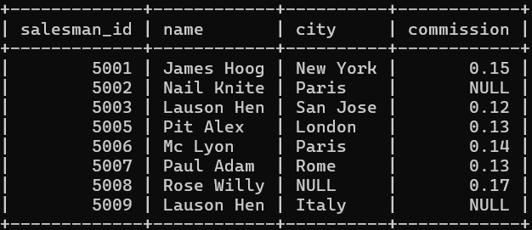

9) Write a SQL statement that displays all the information Sort the output in descending order on salesman_id.

mysql> SELECT * FROM salesman ORDER BY salesman_id DESC;

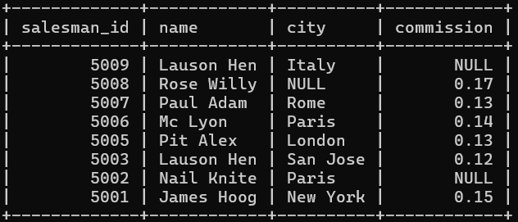

10) Write a SQL statement that displays all the information who live in the city of 'San Jose' AND 'Paris' Sort the output in descending order on salesman_id.

mysql> SELECT * FROM salesman WHERE city='San Jose' and city='Paris' ORDER salesman_id DESC;

Empty set (0.01 sec)

11) write a SQL query to locate who lives in the city of 'San Jose' AND 'Paris' Sort the output in ascending order on salesman_id.

mysql> SELECT * FROM salesman WHERE city BETWEEN 'san jose' and 'paris' ORDER BY salesman_id;

Empty set (0.00 sec)

12) Write a SQL statement who lives in the city of 'San Jose' AND 'Paris' Sort the output in descending order of name.

mysql> SELECT * FROM salesman WHERE city='San Jose' and city='Paris' ORDER BY name

DESC;

Empty set (0.00 sec)

13) Write a SQL query to locate who lives in the city of 'Rome' OR 'London' Sort the output in ascending order on salesman_id.

mysql> SELECT * FROM salesman WHERE city='rome' OR city='london' ORDER BY salesman_id;

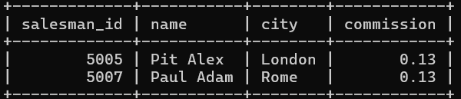

14) Write a SQL query to locate who lives in the city of 'New York' OR 'London' Sort the output in ascending order based on city.

mysql> SELECT * FROM salesman WHERE city IN('new york','london') ORDER BY city;

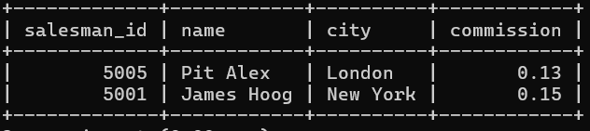

15) write a SQL query to locate who lives in the name of 'James Hoog' OR 'Paul Adam' Sort the output in ascending order on commission.

mysql> SELECT * FROM salesman WHERE name IN('james hoog','paul adam') ORDER BY

commission;

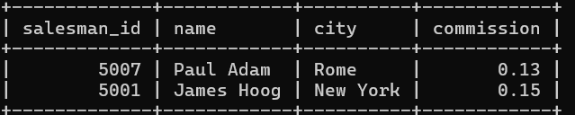

16) Write a SQL statement to display specific columns such as names and commissions, city for all salespeople having commission 0.13.

mysql> SELECT name, commission, city FROM Salesman WHERE commission LIKE 0.13;

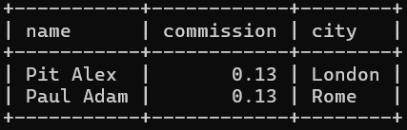

17) Write a SQL statement to display specific columns such as names and commissions for all salespeople having commission greater than 0.12.

mysql> SELECT name, commission FROM salesman WHERE commission>0.12;

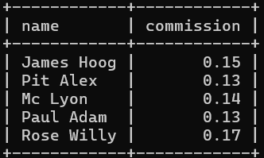

18) Write a SQL statement to display all salespeople having commission greater than 0.12.

mysql> SELECT * FROM salesman WHERE commission>0.12;

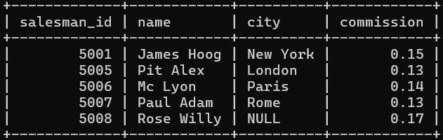

19) Write a SQL statement that displays all the information salespeople having city is NULL.

mysql> SELECT * FROM salesman WHERE city IS NULL;

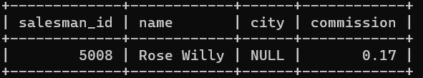

20) Write a SQL statement that displays all the information salespeople having commission is NULL.

mysql> SELECT * FROM salesman WHERE commission IS NULL;

